React 16
- React fibers
- React hooks
- Error boundary
- Fragment
- Automatic Batching for event handlers
React 17
- No need to import “React”
React 18
- Concurrent renderer
- Automatic Batching is scoped even for promises, setTimeout etc
- ReactDOM.render( <App />, document.getElementById("root") ); to =>
const root = createRoot( document.getElementById("root") );
- Extends batching to promises, timers and native eliments
- Suspense-enabled streaming SSR allows the server to progressively send a page to the browser. Components wrapped in Suspense can show fallbacks while their content isn't ready, allowing fast parts of the page to be displayed without waiting for slower parts.
- startTransition tells React: "This update is important, but it doesn't need to happen immediately." As react batches, we can have this priority concept to break in to multiple renders instead of 1
A user action is urgent, but the UI update caused by that action is expensive.
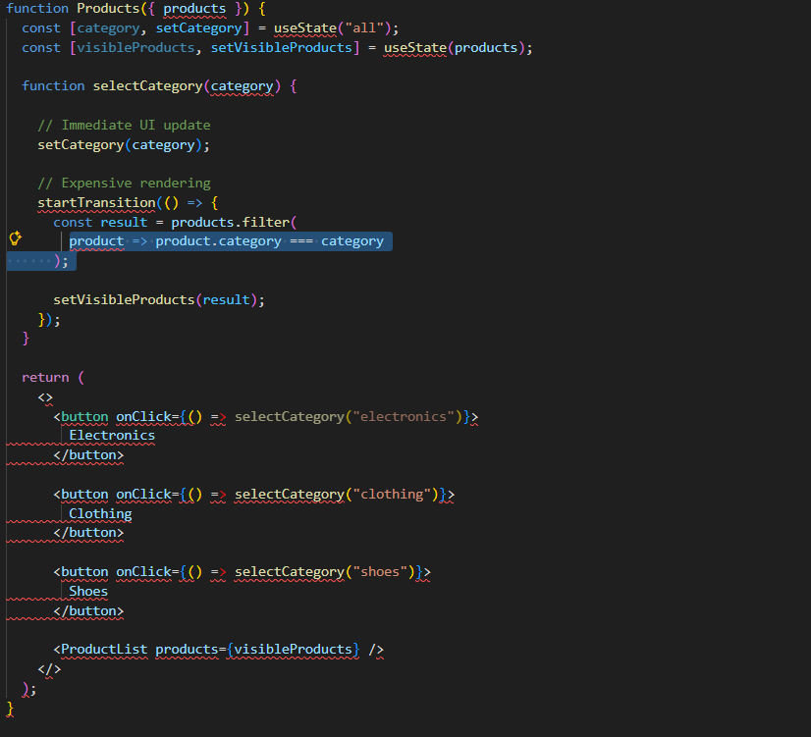
- useDeferredValue
React 19
- ref as a normal prop
- use hook
- useActionState, useOptimistic
- Actions

React is an open-source JavaScript library used for building user interfaces (UIs) in web applications. React follows a component-based architecture, where UIs are broken down into small, reusable pieces called components. When data changes in a React component, React compares the virtual DOM with the actual DOM, identifies the differences, and updates only the necessary parts of the UI, minimizing the number of actual DOM manipulations. Currently it has react fibres where the reconcilation process is updated with multiple phases. Each element in your app is broken down into units of work called fibers.
Concurrent rendering
React can now:
- Split rendering work into small tasks
- Pause rendering mid-way if something more urgent happens
- Continue later, without losing progress
- Let the browser do other things (like handle user input) in between
startTransition(() => {
setFilterResults(filteredList); // Lower priority
});

React Lifecycle methods
- constructor(props): For initializing state and binding event handlers.
- render(): For rendering the component's UI.
- componentDidMount(): For performing side effects after the component has been added to the DOM.
- shouldComponentUpdate(nextProps, nextState): For optimizing rendering by controlling when the component should update.
- getSnapshotBeforeUpdate(prevProps, prevState): For capturing information before the component updates.
- componentDidUpdate(prevProps, prevState, snapshot): For performing side effects after the component updates.
- componentWillUnmount(): For cleaning up resources before the component is removed from the DOM.

What is virtual dom
The Virtual DOM represents a lightweight copy of the real DOM which will be managed by react librari in memory.
React Hooks
- useState
- useRef: In React, the useRef hook is used to create a mutable ref object that can hold a reference to a DOM element or a value that persists across renders
- useEffect
- useLayoutEffect: synchronous useeffect after all dom mutations, like measure size/position/cursor change
- useContext
- useReducer
- useMemo const expensiveValue = useMemo(() => computeExpensiveValue(number), [number]);
- useCallback
- useImperativeHandle: for refs and forward refs
Refs, UseRef & forward ref,
React routers, react router v5 vs v6
----------------------
React and numbers
Redux, Redux store, connect, mapdispatchtoprops, mapstatetoprops, redux thunk, redux saga.
Storybook v6
Jest and Enzyme

useEffect(() => {
const interval = setInterval(() => {
setSeconds(seconds + 1);
}, 1000);

return () => clearInterval(interval); // Cleanup on unmount
}, [seconds]);

const Home = React.lazy(() => import('./pages/Home'));
<Routes>
<Route
index
element={
<React.Suspense fallback={<>...</>}>
<Home />
</React.Suspense>
}
/>

Hooks

Custom useMemo Hook
import { useRef, useEffect } from 'react';

function useMemoCustom(compute, dependencies) {
const computedRef = useRef(null);

if (!computedRef.current) {
computedRef.current = {
value: compute(),
dependencies: dependencies,
};
} else if (!areDependenciesEqual(dependencies, computedRef.current.dependencies)) {
computedRef.current.value = compute();
computedRef.current.dependencies = dependencies;
}

useEffect(() => {
return () => {
computedRef.current = null;
};
}, []);

return computedRef.current.value;
}

function areDependenciesEqual(depsA, depsB) {
if (depsA.length !== depsB.length) {
return false;
}

for (let i = 0; i < depsA.length; i++) {
if (depsA[i] !== depsB[i]) {
return false;
}
}

return true;
}

Eslint:
ESLint is a popular open-source JavaScript linting tool that helps developers identify and fix code issues, maintain consistent coding styles, and improve code quality.

Webpack: javascript module bundler,
Redux flow:


Flow
Redux Thunk: Redux Thunk is a middleware for Redux that allows you to write action creators that return functions instead of plain action objects.

